**EE-1005 Digital Logic Design**

**DLD Project Report: Electronic Dice**

**Made By: Sohaib Sarosh Shamsi 21K-3278**

**Abdullah Gohar 21K-3342**

**Sheza Farooq 21K-3240**

**Course Instructor: Sir Usama bin Umar**



**Table Of Contents:**

* **Title Page pg 1**
* **Table of Contents pg 2**
* **Project Overview pg 3**
* **Circuit Diagram pg 3**
* **Working Of Electronic Dice pg 4**
* **Working OF IC/IC Pictures pg 5**
* **Components and Cost pg 6**
* **Future Work pg 7**
* **Applications pg 7**
* **Refrences pg 7**

***Project Overview:***

Electronic Dice is an instrument which generates random number digitally on a 7 segment. This dice operates at a very high speed and the IC used within it (4017,555 Timer,7447) makes it easy and simple to use.

***Circuit Diagram:***

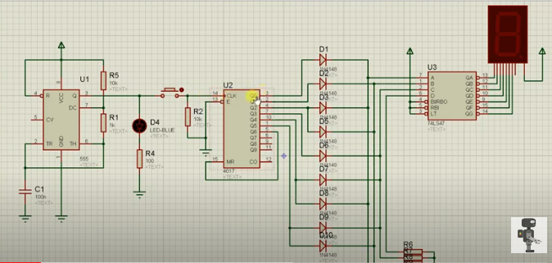

***Working of Electronic Dice:***

The Dice starts of with a 555 Timer IC. It is used to generate clock. If the clock is generated without any error then the power is passed to push button. A resistor is connected with push button. As soon as push button receives power the led lights up making sure that the power is passed from 555 to push button.

Then we have a shift register (4017) which is connected to the push button. We have 9 output in shift register but a dice can only have 6 outputs (1-6). So for that reason the output from (0-5) is given in BCD through wires and the remaining output of 4017 is given back in shift in. So that it keep on shifting and rolling and generating random numbers between (1-6).

We have also connected 9 diodes which ensure that we don’t get and reverse bias from BCD because BCD can give data back to shift register so it can cause error that’s why we have connected diode. Then the output of BCD is connected to 7 segment so that BCD can be decoded and random numbers can be generated in between 1 till 6.

We have also connected resistors because the battery is of 9 volt and the circuit works on 3 volt so to ensure circuit works correctly we have used resistors and that’s how we have made this electronic dice. We can simply press the push button and 7 segment will randomly display numbers between 1-6.

***Working OF IC:***

555 Timer IC: This IC is used to generate clock in our electronic dice.

4017 Shift Register: 4017 IC is a CMOS decade counter chip. It can produce output at the 9 pins sequentially (Q0 – Q8), means it produce output one by one at the 9 output pins.

7447 IC: It takes 6 input from 4017 and is connected with 7 segment so it can decode and can display the output on LED.

* 555 Timer IC

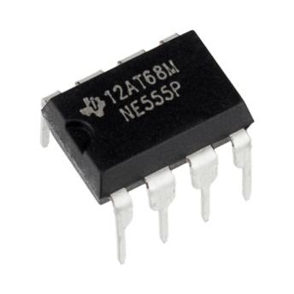

* 4017 Shift Register

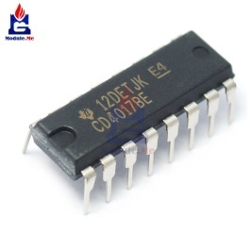

* 7447 IC

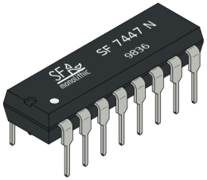

***Components and Cost:***

* Bread Board Rs 150
* Wires Rs 50
* Capacitors Rs 20
* Resistor(1K Ohms)(5) Rs 20 (4Rs Each)
* Resistor (10K Ohms)(5) Rs 25 (5Rs Each)
* Resistor (100K Ohms)(5) Rs 25(5Rs Each)
* Push Button Rs 20
* 7 Segment Display Rs 70
* LED(Green Color)(5) Rs 25 (5Rs Each)
* Battery Rs 90
* Connector Rs 30
* Diode(9) Rs 90
* 555 Timer Rs 45
* 4017 IC Rs 45
* 7447 IC Rs 40

***Future Work:*** Generally dice is made up of wooden or plastic, which gets deformed with time and become biased. A Digital dice is a good alternative of old fashioned dice, it can’t be biased or deformed. It operates at such high speed its hardly possible to cheat.

***Applications of Electronic Dice:***

* Board Games
* Ludo
* Monopoly
* Snake and Ladders

***Refrences:***

[***www.electronicsforu.com***](http://www.electronicsforu.com)

[***www.electronics-project-design.com***](http://www.electronics-project-design.com)